**Facebook Ad Campaign Analysis - Documentation**

**1. Project Title**

**Facebook Ad Campaign Analysis Dashboard**

**2. Objective**

The goal of this project is to analyze the performance of Facebook ad campaigns by tracking key metrics such as conversion rate, cost per click, impressions, sales, and target demographics. The interactive Power BI dashboard provides actionable insights to optimize ad spend and improve targeting.

**3. Data Source**

* The dataset used for this analysis was sourced from **Facebook Ads Manager** reports, exported to **Excel**.
* Data includes metrics like clicks, impressions, conversion rates, ad spend, sales, and audience demographics (age & gender).

**4. Data Transformation & Processing**

* **Power Query** was used for data cleaning and preprocessing.
* **DAX (Data Analysis Expressions)** was applied for creating calculated measures and KPIs.

**5. Key KPIs & Metrics Used**

**Page 1 - Overview & Performance Analysis**

* **Conversion Rate** – Measures the percentage of users who took a desired action.
* **Cost per Mille (CPM)** – The cost per 1,000 impressions.
* **Cost per Click (CPC)** – The amount spent for each click.
* **Click-Through Rate (CTR)** – Percentage of users who clicked on the ad after viewing it.
* **Click per Action (CPA)** – The cost of each user action triggered by the ad.
* **Total Sales** – The number of successful conversions (sales) generated.
* **Total Clicks vs Impressions** – The relationship between ad impressions and clicks.
* **Demographic Analysis**
  + Gender-wise and age-wise distribution of engagement.
  + Gender-wise age group sales.
  + Gender-wise spending distribution.
* **Navigation:** Clicking the **Facebook logo** redirects users to **Page 2** for deeper insights.

**Page 2 - Target Audience & Ad Optimization**

* **Target Customers** – Identifies high-converting audience segments based on age and gender.
* **Top 5 Target Categories** – Categories with the highest conversion rates.
* **Impressions Distribution by Age & Gender** – Pie chart showing ad impressions across different demographics.
* **Top Selling Ads** – List of ads with the highest engagement, conversions, and spending.

**6. Dashboard Design & Features**

* **Color Theme:** A **Facebook-inspired blue theme** for consistency and brand alignment.
* **Visuals Used:**
  + **Cards & KPI tiles** for key performance indicators.
  + **Gauge Charts** for total sales and impressions.
  + **Bar Charts** for gender-wise and age-wise sales analysis.
  + **Pie Chart** for impression distribution.
  + **Tables** for top target categories and top-selling ads.
* **Interactivity:**
  + Clicking the **Facebook logo** navigates to **Page 2**.
  + Filters for **Gender** selection.
  + Dynamic tooltips for additional data insights.

**7. Challenges & Solutions**

* **Data Volume:** Optimized DAX calculations to handle large datasets efficiently.
* **Navigation Between Pages:** Implemented a clickable logo for seamless navigation.
* **Ad Performance Metrics Calculation:** Used DAX for custom KPIs such as CTR, CPM, CPC, and CPA.

**8. Future Enhancements**

* **Live Data Integration:** Connecting the dashboard directly to Facebook’s API for real-time updates.
* **Predictive Analysis:** Using machine learning models to forecast ad performance.
* **Cost Optimization Suggestions:** Implementing AI-driven insights to suggest budget reallocations for better ROI.

**DASHBOARD:**

**Page – 1**

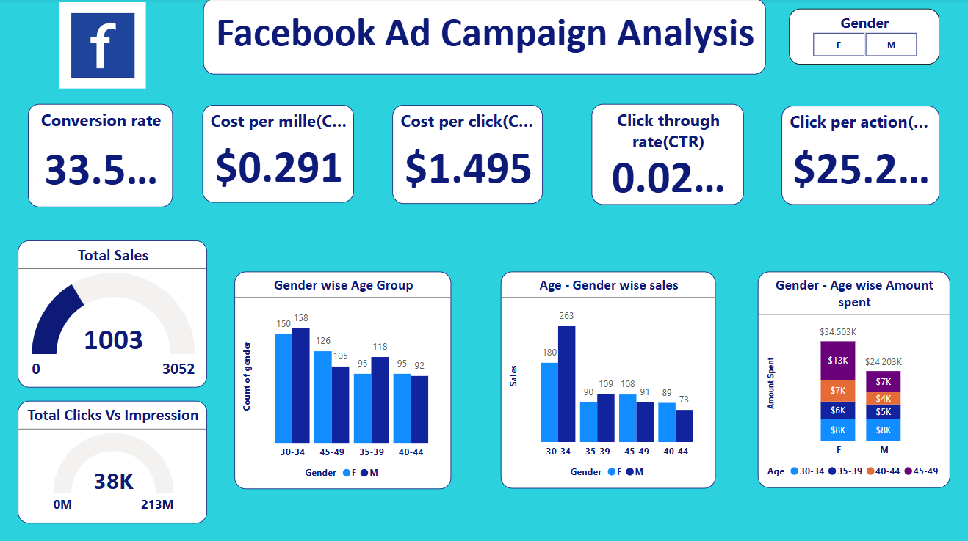

**Page – 2**

